


West Coast Collaborative

Mathematics Specialist Unit 4

Test 5 2018: Applications of Differentiation

Student Name: _____________________________

Section One – calculator-free section

Time allowed for this task: 30 minutes, in class, under test conditions.
All electronic devices must be switched off and stored in students’ bags.

Materials Provided: SCSA Formula Sheet

Materials required: (to be provided by the student)

Standard items: Pens (blue/black preferred), pencils (including coloured), sharpener, correction fluid/tape, eraser, ruler, highlighters.

Marks available: 30 marks

1. [2, 4, 2 = 8 marks]

a) If $x^{2}-xy+y^{3}=8$, determine an expression for $\frac{dy}{dx}$.

b) For the curve $x^{3}+y^{3}=35$, determine the equation of the tangent to the curve in exact form that is
i) at the point with an $x-$value of 2,

ii) parallel to the $x$-axis.

2. [2, 3 = 5 marks]

Solve the following differential equations:

a) $\frac{dy}{dx}=\sin^{2}x$ , given that $y\left(0\right)=\frac{1}{2}$

b) $\frac{dy}{dt}=2e^{2t}-e^{-t}$, given that $y=2.5 when t=ln2$

3. [5 marks]

Use separation of variables and partial fraction techniques to determine the particular solution to

$\frac{dy}{dx}=\frac{3y-xy}{x^{2}-1}$, given that $y\left(0\right)=1$.

4. [1, 4 = 5 marks]

The slope field for the differential equation $\frac{dy}{dx}=x\left(y-1\right)$ is shown below.

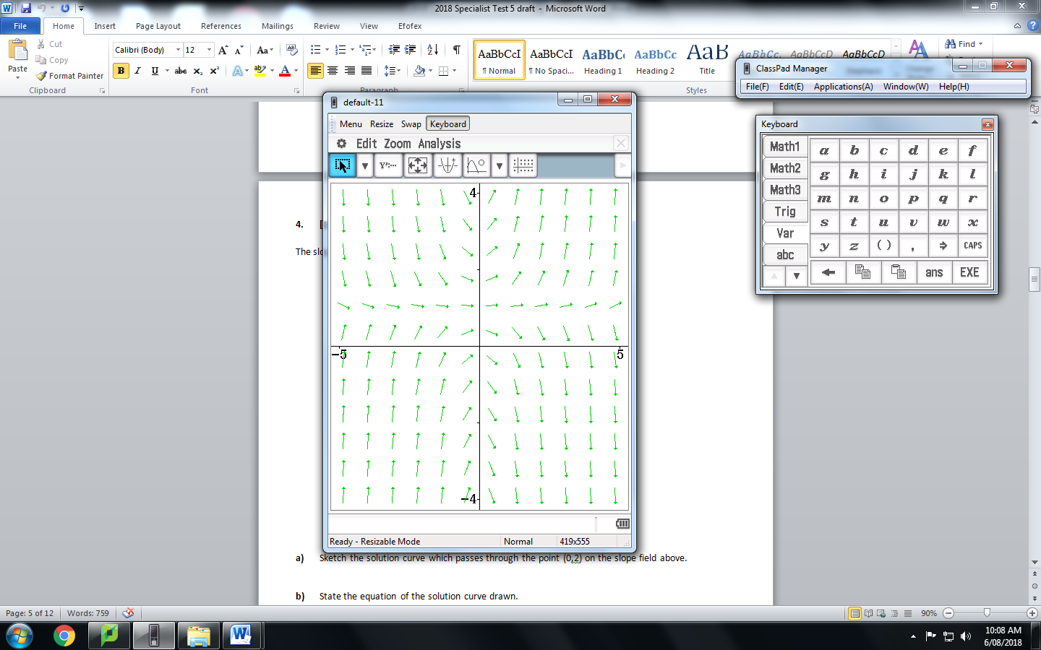

a) Sketch the solution curve which passes through the point (0,2) on the slope field above.

b) State the equation of the solution curve drawn.

5. [ 2, 3, 2 = 7 marks]

A particle moves with velocity $v=2\sqrt{x}$ ms⁻¹ , where $x$ is the displacement. The particle is initially 2 metres to the right of the Origin.

a) Show that the particle has constant acceleration.

b) Express $x$in terms of $t$.

c) Express $v$and $a$ in terms of $t$.

End of Section One



West Coast Collaborative

Mathematics Specialist Unit 4

Test 5 2018: Applications of Differentiation

Student Name: _____________________________

Section Two – calculator-assumed section

Time allowed for this task: 25 minutes, in class, under test conditions

Materials Provided: SCSA Formula Sheet

Materials required: (to be provided by the student)

Standard items: Pens (blue/black preferred), pencils (including coloured), sharpener, correction fluid/tape, eraser, ruler, highlighters.

Notes on one unfolded sheet of A4 paper.

Special items: Drawing instruments, templates, and up to three calculators approved for use in WACE examinations.

Marks available: 25 marks

6. [6, 2 = 8 marks]

A spherical raindrop is formed by condensation. In an interval of 40 seconds its volume increases at a constant rate from 0.032 mm³ to 0.256 mm³.

a) Determine the rate, to two decimal places, at which the surface area of the raindrop is increasing when the radius is 0.5 mm.

b) Using the incremental formula, estimate how much larger will the surface area be when the radius increases from 0.5 mm to 0.55 mm ?

7. [1, 4, 2, 2 = 9 marks]

The population of thorny devils in a remote area has a growth rate of 10% with a limit of 3000.

a) Based on this information, construct a logistic differential equation for this situation in the form $\frac{dP}{dt}=aP(b-P)$,
where $t$ represent the time in years from now.

b) The population is currently 500. State the solution as a logistic function ie. write P as a function of $t$.

c) Determine the expected population after 8 years.

c) Determine the expected time for the population to reach 2000.

8. [ 3, 5 = 8 marks]

A cool room for storing food is refrigerated so that the temperature in the room, F, in degrees Celsius, at t hours after midnight, is given by the formula
F = −4 cos $\frac{π(t-3)}{12}$ for 0 ≤ t ≤ 24
a) Show that F experiences fluctuations that are similar to a particle undergoing simple harmonic
motion.

b) The refrigeration system automatically switches on when the rate of change of
temperature, with respect to time, is greater than or equal to 0.5°C/h. When the rate of
change of temperature, with respect to time, is less than 0.5°C per hour it automatically
switches off again. Find the actual times (e.g. 2.17 a.m.), to the nearest minute, at
which the system switches on and then switches off, during a 24 hour period.

End of Section Two

